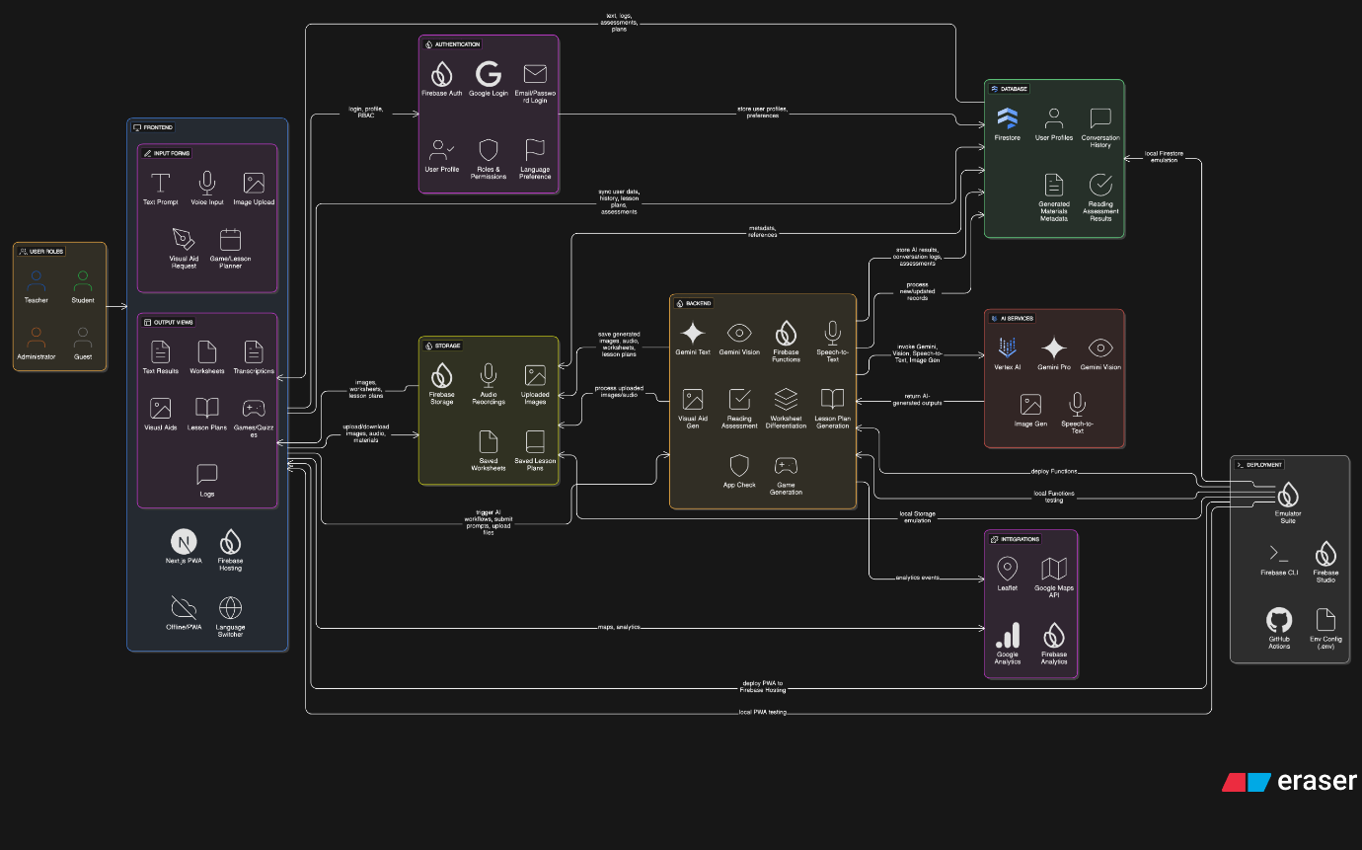

**Google Cloud Architecture for “Sahayak” AI Teaching Assistant**

**Frontend**

* **Firebase Hosting**
  + Next.js (PWA support for low-resource areas)
  + Language switcher (Hindi, Marathi, Tamil, etc.)
  + Inputs:
    - Text prompts (knowledge base questions)
    - Voice input (teacher requests, student reading)
    - Image upload (textbook pages for worksheets)
    - Visual Aid description (for line-drawing generation)
    - Game / lesson planner forms
  + Outputs:
    - Gemini text generation results
    - Differentiated worksheets
    - Transcriptions
    - Generated images
    - Games/quiz formats
    - Lesson plans
  + Conversation logs view

Features:

* Responsive design for mobile access
* Offline-ready with PWA install

**Authentication and User Management**

* **Firebase Auth**
  + Email/password or Google login
  + RBAC (teacher roles if needed)
  + User profile & language preference

**Storage**

* **Firebase Storage**
  + Audio recordings
  + Uploaded textbook images
  + Generated images (visual aids)
  + Saved worksheets / lesson plans

**Database**

* **Cloud Firestore**
  + User profiles
  + Conversation history
  + Saved lesson plans
  + Generated materials metadata
  + Student reading assessment results

Features:

* Offline sync support for low-bandwidth
* Structured queryable content

**Backend Processing / Cloud Functions**

* **Firebase Functions**
  + Secure server-side logic:
    - Speech-to-Text pipeline with Vertex AI
    - Gemini text generation
    - Gemini Vision image analysis
    - Image generation for visual aids
    - Reading assessment scoring
    - Worksheet differentiation prompts
    - Lesson plan generation
    - Educational game generation
  + App Check enforced for security

Benefits:

* Scalable, event-driven
* Can be tested with Emulator Suite

**AI Services**

* **Vertex AI**:
  + Gemini Pro / Gemini 1.5 for:
    - Text generation (knowledge base Q&A, lesson plans, games)
    - Differentiated worksheet generation
    - Multi-language content creation
  + Gemini Vision:
    - Textbook page image analysis
    - Worksheet generation from images
  + Vertex AI Speech-to-Text:
    - Teacher voice input transcription
    - Student reading assessment transcription
  + Vertex AI Image Generation (if available):
    - Simple blackboard-friendly line art generation

**Deployment / DevOps**

* **Firebase CLI + GitHub Actions (optional)**
  + Build, test, and deploy to Firebase Hosting & Functions
  + Use Emulator Suite for local development
  + Manage environment configs with .env files
* Firebase Studio for deployment interface

**Optional Integrations**

* Google Maps API or Leaflet for local map integration (if needed for lesson materials)
* Google Analytics / Firebase Analytics for usage tracking

**Frontend**

* Firebase Hosting / Next.js (PWA)
* Input forms (text, voice, image, planning)
* Output views (cards/lists, worksheets, games, plans)

**Auth**

* Firebase Auth

**Storage**

* Firebase Storage (images/audio/materials)

**Database**

* Firestore (user data, history, assessments)

**Backend**

* Firebase Functions
  + Speech-to-Text (Vertex AI)
  + Gemini text generation
  + Gemini Vision
  + Reading assessment
  + Image generation for visual aids

**AI Services**

* Vertex AI
  + Gemini Pro
  + Gemini Vision
  + Speech-to-Text

**Deployment**

* Firebase CLI, Emulator Suite
* Firebase Studio, GitHub Actions.

1. Chatgpt content paathaley theriyuthu – make it looks like humanized ones
2. I have to learn about the implemenetation a stuffs also need to get the flow of some workflows
3. I should not think about me as I can win just by the sitrinbam
4. IEEE paper
5. Team meet
6. Number vaanga marandhuttan

Win panra varaikkum moochu vida koodathu

27th July competition mudiyuthu athukkulla naa COE la join panni, learn pannanum

2 weeks than irukku:

I have set my aura badly by imagining me as the winner in a correct ratio , I should not underestimate the bad aura that could follow me as happened in the Micorsoft innovation Challenge – Solution: 3 to 5:30 study is must, eating and physique maintainance has to be fixed,

Naa athey time la matha Stuffs vitra mudiyaathu just like the aptitude , and the Academics notes , and the IA , My project refining ,

Innaikku submit panrathukku munnadi pray pannittu submit panran , and then before 10 all of ths stuff has to be completed